# Access Code Struggle

Opening Note: This struggle was a result of poor documentation from the previous team. I did not know how to create a user, let alone an access code. This documentation shows my steps in how I tried to make an access code, connect it to a user, and try to run the program. In doing so, I’ve learned a lot about the database, but I never got the access code to work using this method.

Hence, **this document is deprecated because following these steps does not yield a working access code. This guide is only great for teaching someone how to navigate SQLite, add rows/columns, and learn about the database.**

Final Note: There is an easier way to make an access code with the program. Access Codes are made when you create a user and are automatically assigned as such. See the Word Document on Making a User with the Program. Creating an access code by adding values to the database directly is very complicated and will not work.

## Opening the Database with SQLite

* You will need SQLite to open this database. You can download it at: <https://sqlitebrowser.org/dl/>

1. Open ScavengeRUS.db.
2. You should see a screen like this. If not, ensure the program opens with SQLite.
   1. SQLite’s executable is located at C:\Program Files\DB Browser for SQLite. Open the program with the executable located in this folder.

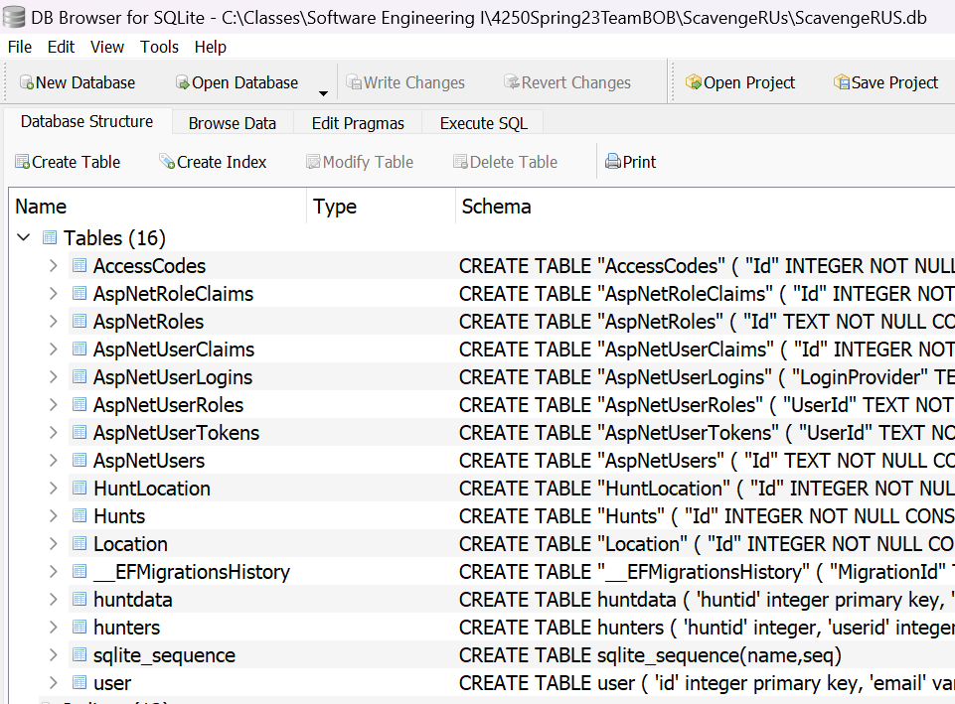

1. Click on “Browse Data” on the top menu.



1. You should see a screen like this:
   1. If not, you are probably on the wrong table.
   2. Change your table by clicking on the “Table: ” drop-down list (Highlighted in red below), and change it to AccessCodes.



1. Add a new AccessCode by pressing the table with a plus icon (highlighted in Green above). You should see the resulting menu:

1. Move this menu so you can see the table data and the menu simultaneously.

1. The Id and Code fields are unique. However, HuntId is not unique. Ensure that whenever adding an AccessCode to the database, the Id and Code you input are different than all the IDs and Codes in the database.
2. After adding the AccessCode, you might think that you’re done. However, when you try to open this accesscode in the program, it fails! We need to look at AccessCode’s dependencies. What else does it need?
3. To get a feel of AccessCode’s dependencies, open the AccessCode.cs class in Visual Studio. It’s located at: Models\Entities\AccessCode.cs

* 1. Note that the AccessCode we made contains 3/5 fields already filled out. We just need to connect this AccessCode to a Hunt and Users.

1. Open the “Hunts” table in the database. You should see something like this:

1. Make a new hunt by pressing the  icon. The Id here corresponds to HuntId in AccessCode. If you made an AccessCode, ensure that the HuntId (in AccessCode) in corresponds to Id (in Hunts).









1. Lastly, Users.

[End of Document]

Final Note: There is an easier way to make an access code with the program. Access Codes are made when you create a user and are automatically assigned as such. See the Word Document on Making a User with the Program. Creating an access code by adding values to the database directly is very complicated and will not work.